**Virtual Key for Your Repository Application Prototype**

End of Phase 1- OOPS Using Java Data Structures

**Student : Swapnil Devkar**

[er.swapnil1315@gmail.com](mailto:er.swapnil1315@gmail.com)

Full Stack Java Developer Master’s Program

Summer 2023

Table of Contents

Overview ....................................................................................................…............... 2

Problem Statement......…….......................................................................…................. 2

Agile Project Management....................................................….................................... 3

Implemented Java Concepts................................................................................…...... 5

Packages.............................................................................…………............................... 5

Classes, Objects, & Methods.............................................................................……...... 5

Static Initialization Variables,Block ...........................................................….............. ..5

Static Class Methods..............................................................................….................. .6

Console Input and Output.........................................................................…………...... .7

Control Statements...........................................................................…....................... 7

File I/O..............................................................................................................……..... 7

Showing the list of files in the directory ......................................................………....….7

Flow Chart.................................................................................................................. .8

Code Screenshots ...................................................................................................... .9

Test cases output Screenshots .................................................................…............. 12

GitHub Repository ............................................................................…...................... 15

**Overview**

****Objective:****

The main objectives of Phase 1 of the Simplilearn Full Stack Java Development program were

• to gain an understanding of core concepts of the Java Programming Language (abstraction, polymorphism, inheritance, and encapsulation),

• embrace the Eclipse Integrated Development Environment (IDE),

• understand the Agile software development life cycle

• gain familiarity with Java data structures for object-oriented applications.

****Problem Statement:****Company Lockers Pvt. Ltd. hired you as a Full Stack Developer. They aim to digitize their products and chose LockedMe.com as their first project to start with. You’re asked to develop a prototype of the application. The prototype of the application will be then presented to the relevant stakeholders for the budget approval.

Lockers Pvt. Ltd. would like a presentation on the following topics in the next 15 working days (3 weeks):

* Specification document - Product’s capabilities, appearance, and user interactions
* Number and duration of sprints required
* Setting up Git and GitHub account to store and track your enhancements of the prototype
* Java concepts being used in the project
* Data Structures where sorting and searching techniques are used.
* Generic features and three operations:
* Retrieving the file names in an ascending order
* Business-level operations:
* Option to add a user specified file to the application
* Option to delete a user specified file from the application
* Option to search a user specified file from the application
* Navigation option to close the current execution context and return to the main context
* Option to close the application

**Agile Project Management**

This section will cover the project management details surrounding the software development life cycle for the virtual keys repository application prototype.

****Project Overview :****

* Client - Lockers Pvt. Ltd
* Consultant - Swapnil Devkar (Full Stack Java Developer )
* Application Name - LockedMe.com
* Application Phase - Prototype
* Phase 1 Project Deliverable - Console-based virtual keys repository Application

****Project Planning Management :****

* Project Duration - 3 Weeks (15 working days)
* Number of Sprints - 3
* Planned Sprint Duration - 1 Week (5 working days)
* Total Number of Product Backlog Items - 14

Application User Roles

General User - The General User will use the prototype application for file handling.(Initial Release )

Admin - The Admin will use the protype application for maintaining users and setting user directory & file permissions. (Future Release)

Project Planning Details

|  |  |  |  |  |
| --- | --- | --- | --- | --- |
| **Sprint No** | **Sprint Dur.** | **Plan Start Date** | **Plan Finish Date** | **Product Backlog Items** |
| 1 | 1 Week | 21/01/2023 | 27/01/2023 | Welcome Screen List  Main Menu Options List |
| 2 | 1 Week | 28/01/2023 | 03/02/2023 | Business Level Menu Options List |
| 3 | 1 Week | 04/02/2023 | 11/02/2023 | Business Level Menu Options Add/Delete/Search |

Product Backlog

|  |  |  |
| --- | --- | --- |
| **Backlog Item (User Story)** | **Story Points** | **Assigned Sprint** |
| LockedMe.com application will present Welcome Screen on the console.In Welcome Screen Show Application name, developer name | Small | 1 |
| In Welcome Screen Option to proceed ahead | Small | 1 |
| Application should present 3 option that is in main menu | Small | 1 |
| In the first main menu option should retrieve  the current file names in an ascending order. | Medium | 2 |
| Files are sort in ascending order and  display the resultant list on the console. | Medium | 2 |
| In Second Option business level options menu 4 option display. | Small | 2 |
| In first business level operation is to a ADD new file in the target directory. | Medium | 2 |
| The second business level operation is to a Delete file in the target directory.In this operation first check file exist or not. Once File Found in directory ask the User for confirmation prior to file deletion. | Medium | 3 |
| The third business level operation is to SEARCH for a user-specified file in the target directory.In this operation first check file exist or not. Once File Found in directory then showing messages for successful. | Medium | 3 |
| The fourth business level operation is to provide the option to GO BACK to the main  menu. | Small | 3 |
| The third main menu option should trigger application close | Small | 3 |

## Implemented Java Concepts

In this section highlighted the Java concepts used to create the virtual keys repository application prototype

### Packages

Package dedicated to the practice problems for the Simplilearn program.

### Classes, Objects, & Methods

A class is **a group of objects which have common properties**. In the project class name is “FirstApplication”

A Java object is **a member (also called an instance) of a Java class**. In the project I created object of “FirstApplication” Class

A method in Java is **a block of code that, when called, performs specific actions mentioned in it**. The main() method is the only publicly available method, which is of course static. Since all the code for the Lockedme.com application was written in a single file, static methods can be calling using method name.

Static Initialization Variables -

A **variable is a container which holds the value while the Java program is executed**. In the application declare private static variables like “rootFolderPath”,”fileName”,”selFile” etc.  
  
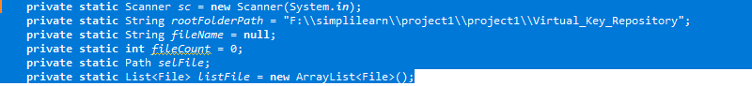

### Static Class Methods

A method in Java is **a block of code that, when called, performs specific actions mentioned in it**. The main() method is the only publicly available method, which is of course static. Since all the code for the Lockedme.com application was written in a single file, static methods can be calling using method name.

Console Input and Output

Retrieve data from the console (using the System.in object to create a stream for the console input)

Output messages to the console (using the System.out object and associated methods to output data to the console)

### Control Statements

In this application use while loop and switch statement.

while loop – Controls the program flow by prompting the User for main menu and the business options sub-menu, performing the desired operations, and terminates when the User wishes to quite the program.

switch statement – Executes the desired code statements associated with the main menu and the business level options sub-menu based on the value entered by the user.

File I/O

In the application root directory is “F:\\simplilearn\\project1\\project1\\Virtual_Key_Repository”

In the application for display files in directory use “showAllFiles” method created. Created root file directory object and using loop display files name.





## Flow Chart

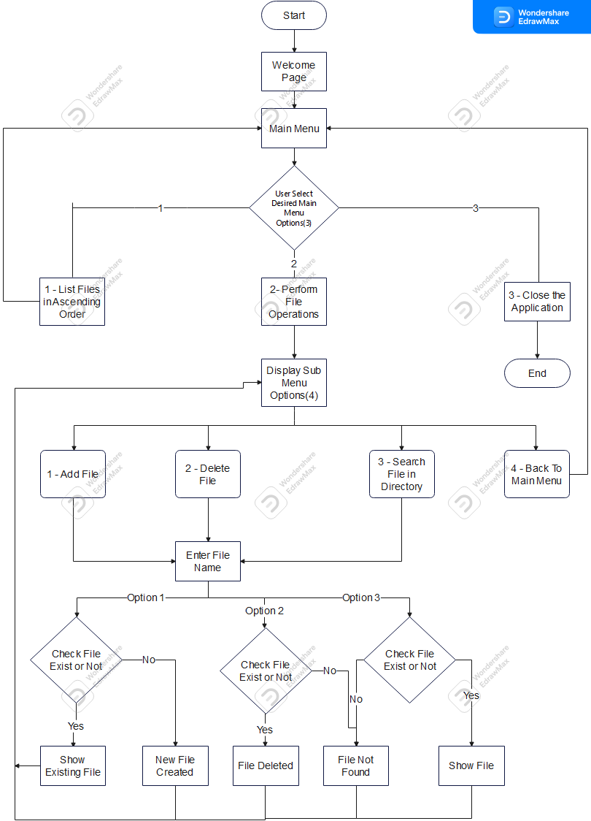

## Code Screenshots

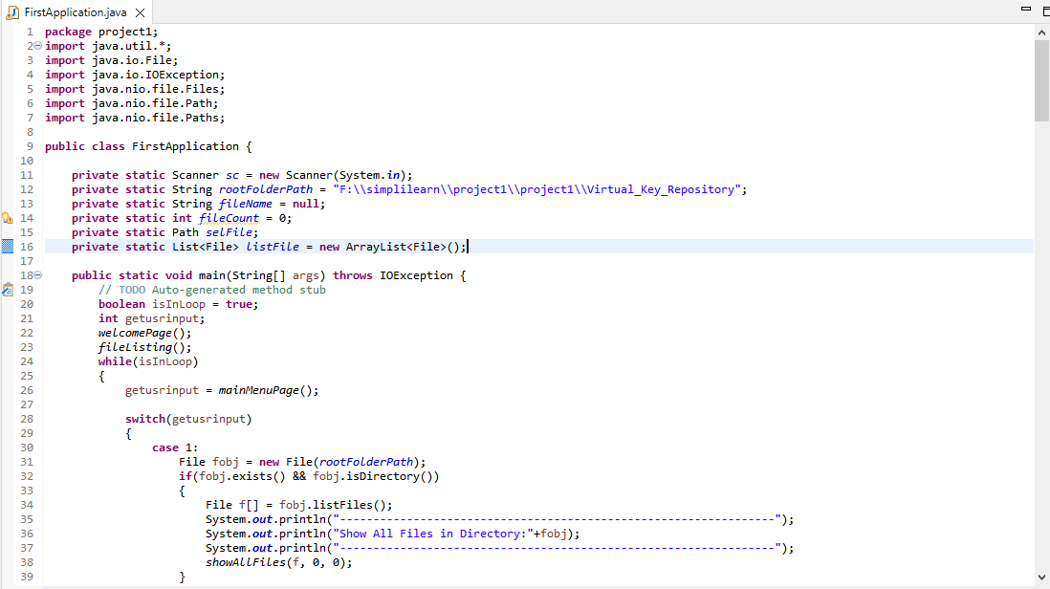

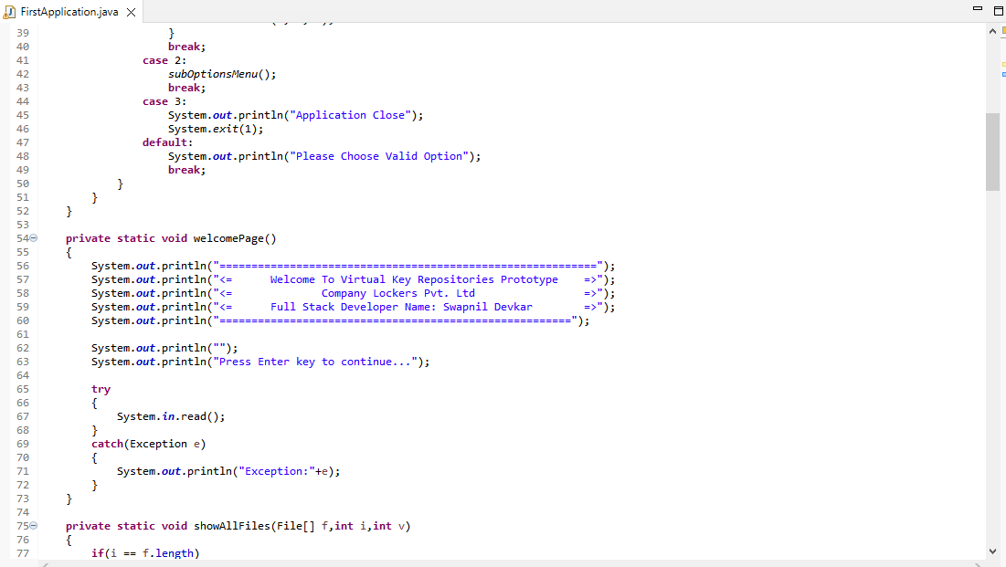

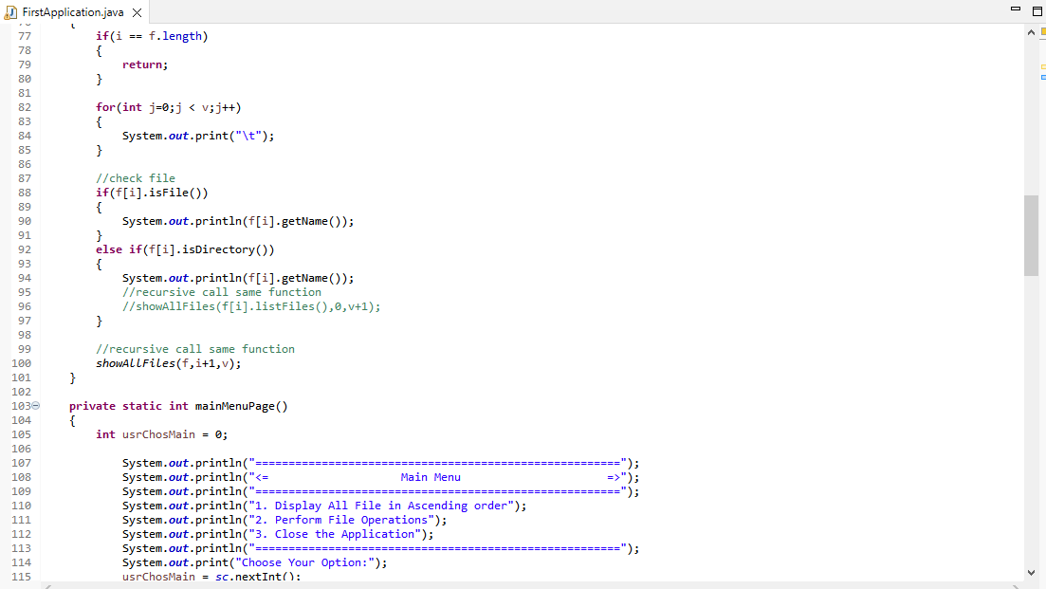

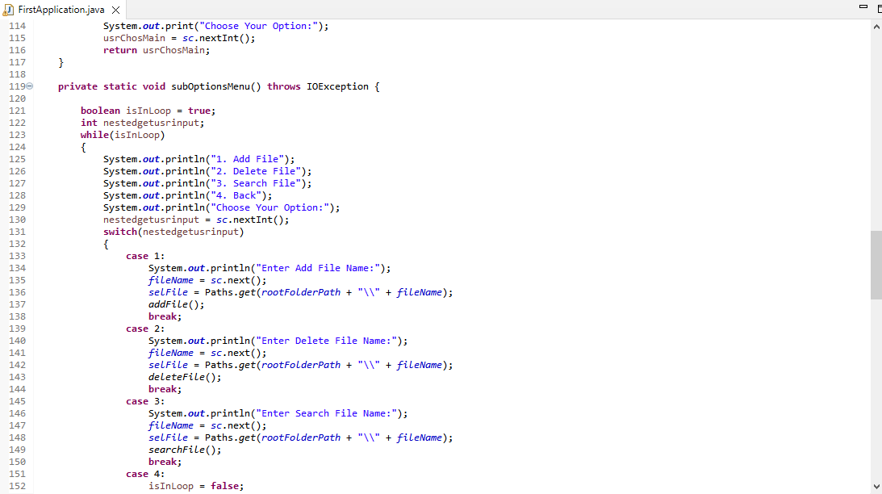

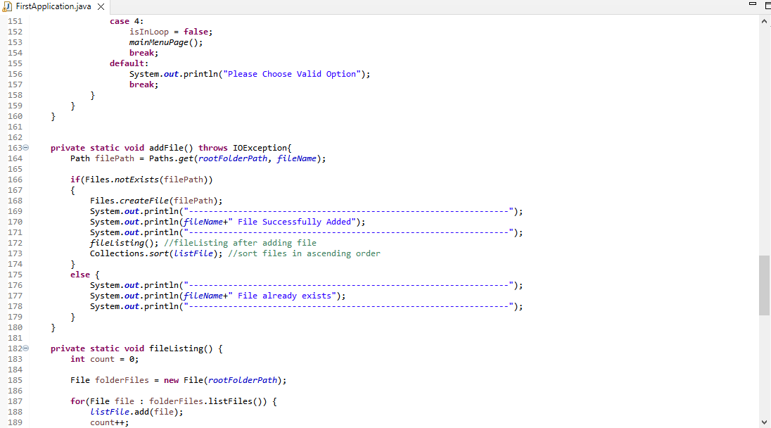

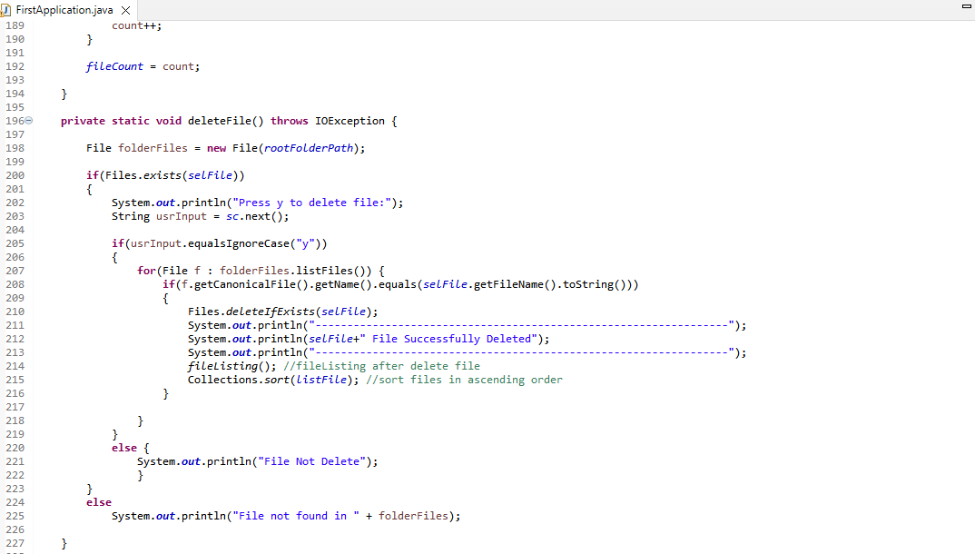

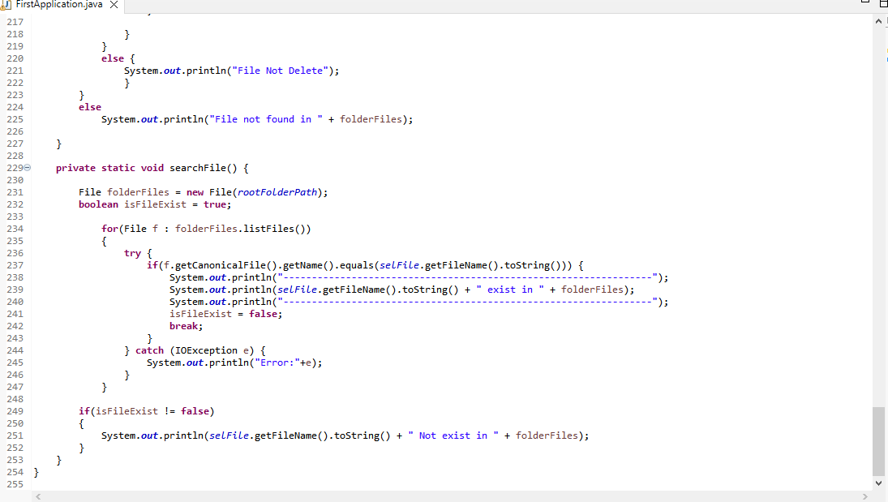

**Test Cases Output Screenshots-**

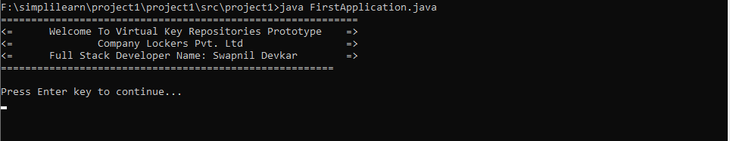

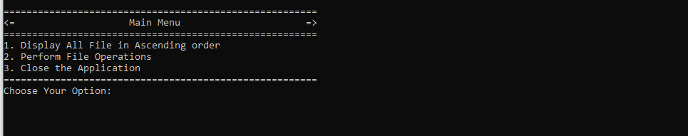

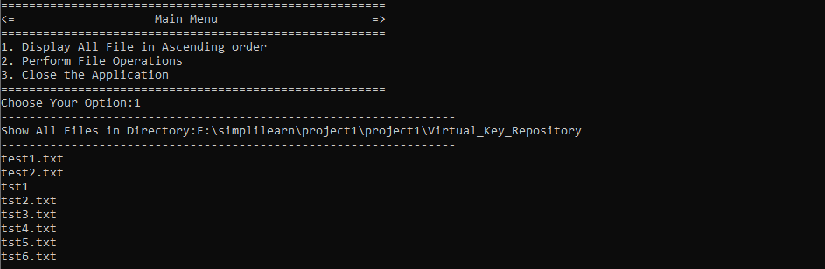

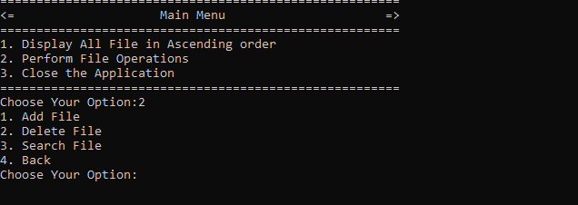

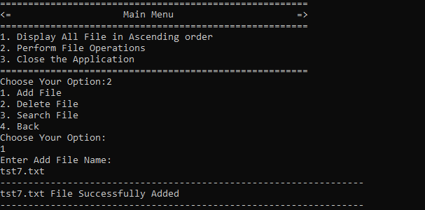

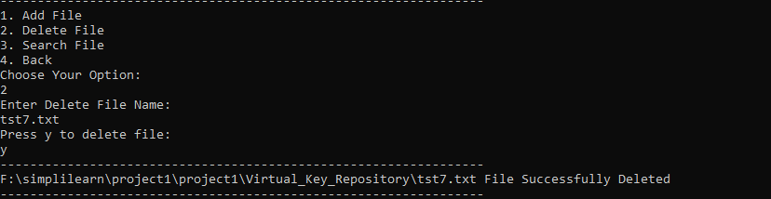

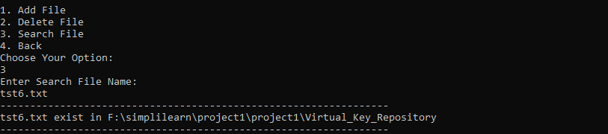

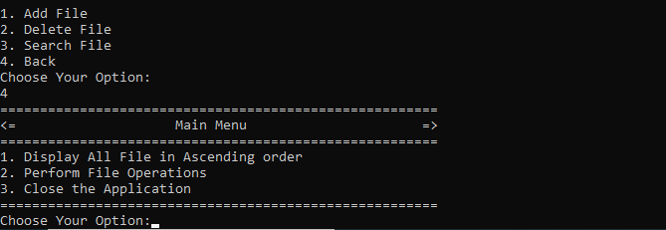

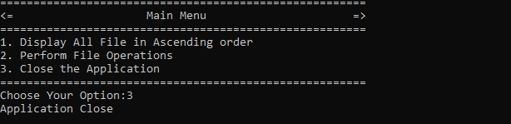

## GitHub Repository

I have pushed my code and associated documentation to the following GitHub repository:

https://github.com/swapnil130994/Virtual-Key-for-Your-Repository-Application-Prototype